**BINGO BONUS (10 POINTS):**

Run the following SAS program:

**data** TEMPFILE;

label Y = "High Monthly use of steam (in pounds)";

label X8 = "Average temperature (F)";

input Y X8;

cards;

1 35.3

1 29.7

1 30.8

0 58.8

1 61.4

1 71.3

0 74.4

0 76.7

0 70.7

1 57.5

0 46.4

1 28.9

1 28.1

1 39.1

1 46.8

1 48.5

1 59.3

0 70.0

0 70.0

1 74.5

0 72.1

0 58.1

1 44.6

1 33.4

1 28.6

;

run;

**proc** **logistic** data=TEMPFILE;

model Y = X8;

score data=TEMPFILE out=OUTFILE;

**run**;

**proc** **print** data=OUTFILE noobs;

var Y P_0 P_1;

**run**;

When you do, you should get the following output::

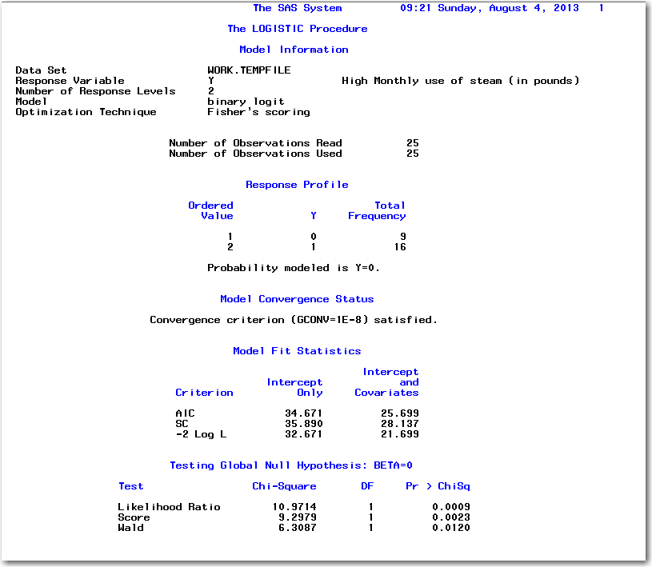

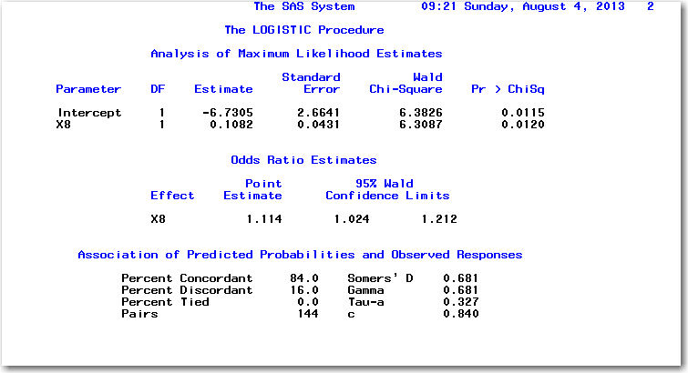

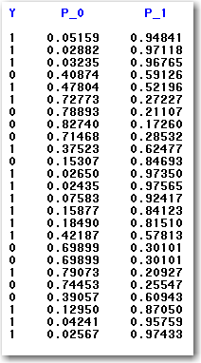

BONUS WORK:

Copy the output values “Y”, “P_0”, and “P_1” into an excel spread sheet.

Using EXCEL, I want you to calculate the following numbers:

* -2 Log L Intercept Only (hint: use average of “Y” for P_1 and 1-avg Y for P_0
* AIC Intercept Only
* SB Intercept Only
* -2 Log L Intercept and Covariants
* AIC Intercept and Covariants
* SB Intercept and Covariants
* Likelihood Ratio Test Values
* According to AIC, is the model better than the intercept only? Why?
* According to SB, is the model better than the intercept only? Why?
* According to Likelihood Ratio Test, is the model better than the intercept only? Why?

Things to Consider:

1. Your EXCEL file should be using FORMULAS. Don’t just type in the values for -2 Log L, AIC, SB by hand. The point is that I want to know that you know how to calculate these values.
2. Hint: in EXCEL the formula for natural log is “LN” and not “LOG”. So you should be using “ln(P_1)” and ln(P_0) and not “log(P_1)” and “log(P_0)”.

**DOUBLE SECRET PROBATION**

**BINGO BONUS (10 POINTS):**

If you really want to impress me, calculate these:

* Percent Concordant
* Percent Discordant
* Percent Tied
* Pairs
* Somers’ D
* Gamma
* Tau-a
* C

HOW TO SUBMIT YOUR BINGO BONUS WORK:

1. Go to your Excel File and HIGHLIGHT the answers so I know what I am looking for
2. Rename Your Excel File to be LOGIT_METRIC_lastname_firstname.xlsx
3. Email the Excel File to your instructor

FINAL THOUGHTS:

1. Grading extra work like this is time consuming. I don’t have time to go back and give you points that I overlooked the first time. Make it clear where everything is!
2. In other words: **ALL SALES ARE FINAL !** ☺